TOOLKIT
Difference in Differences

August 2020
- BACKGROUND

- Difference in Differences is a quasi-experimental design that makes use of longitudinal data from treatment and control groups to obtain an appropriate counterfactual to estimate a causal effect.
- DID is typically used to estimate the effect of a specific intervention by comparing the changes in outcomes over time between a population that is enrolled in a program (the intervention group) and a population that is not (the control group).
- It is used in observational settings where exchangeability cannot be assumed between the treatment and control groups. DID relies on a less strict exchangeability assumption, i.e., in absence of treatment, the unobserved differences between treatment and control groups are the same overtime. Hence, Difference-in-difference is a useful technique to use when randomization on the individual level is not possible. DID requires data from pre-/post-intervention, such as cohort or panel data (individual level data over time) or repeated cross-sectional data (individual or group level). The approach removes biases in post-intervention period comparisons between the treatment and control group that could be the result from permanent differences between those groups, as well as biases from comparisons over time in the treatment group that could be the result of trends due to other causes of the outcome.
DID usually is used to estimate the treatment effect on the treated (causal effect in the exposed), although with stronger assumptions the technique can be used to estimate the Average Treatment Effect (ATE) or the causal effect in the population.
- DiD estimates are based on the difference in the changes in the outcome between treatment and comparison groups over time. Fixed effects models combine differencing with multivariate models that can account for differences in observed variables over time.
- The method takes the trajectory of the comparison group as the counterfactual trajectory for the treatment group. That is, the change in the outcome that takes place in the comparison group is taken as what would have happened to the treatment group in the absence of the intervention. Therefore, subtracting the change in the outcome observed in the comparison group from that observed in the treatment group gives the measure of impact. The effects of all factors that do not change over time or that do not affect changes over time are thereby eliminated from the impact estimate. Many determinants of program placement or participation can be expected to be rather time invariant, hence the attractiveness of this approach.

- ASSUMPTIONS

When doing a DiD method analysis we assume that the composition of the groups being studied are stable over the time period we are concerned about. We also assume there are no spillover effects, the amount of treatment or intervention given is not determined by the outcome, and that both groups being studied have parallel trends in their outcome—i.e., if no treatment was given, the difference between the data from the two groups would have a consistent difference over time
Most of the assumptions for DiD are the same as The Ordinary Least Squares Model (OLS), which are as below:
- The linear regression model is “linear in parameters.
- There is a random sampling of observations.
- The conditional mean should be zero.
- There is no multicollinearity (or perfect collinearity).
- Spherical errors: There is homoscedasticity and no autocorrelation
- Error terms should be normally distributed

Additionally, it is assumed that:
- Intervention is unrelated to outcome at baseline; allocation of intervention is not determined by outcome.
- In the absence of treatment, the difference between the ‘treatment’ and ‘control’ group is constant over time. This is called the parallel trends assumption.
- Composition of intervention and comparison groups is stable for repeated cross-sectional design.
- No spill-over effects.
- STEPS INVOLVED IN DiD
The basic DiD method involves comparing results from two groups, with data from each group being recorded over two time periods. One group (the control group) is not exposed to any treatment or intervention whatsoever; the other (treatment group) is exposed to a treatment or intervention before or during one of the two time periods. The same observations are made in both groups over each time period.
The below figure illustrates the difference-in-differences method.
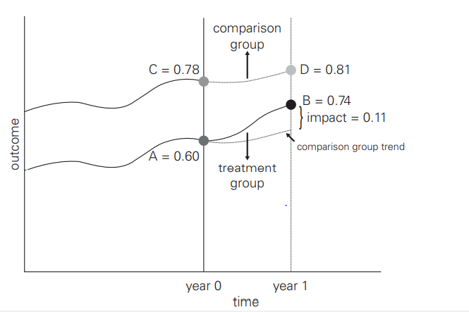
Source – World Bank - Difference-in-Differences
A treatment group is enrolled in a program, and a comparison group is not enrolled. The before-and-after outcome variables for the treatment group are A and B, respectively, while the outcome for the comparison group goes from C, before the program, to D after the program has been implemented. You will remember our two counterfeit counterfactuals—the difference in outcomes before and after the intervention for the treatment group (B − A) and the difference in outcomes 2 after the intervention between the treatment and comparison groups (B − D). In difference-indifferences, the estimate of the counterfactual is obtained by computing the change in outcomes for the comparison group (D − C). This counterfactual change is then subtracted from the change in outcomes for the treatment group (B - A). In summary, the impact of the program is simply computed as the difference between two differences: DD impact = (B − A) − (D − C) = (B − E) = (0.74 − 0.60) − (0.81 − 0.78) = 0.11.
The relationships presented in figure can also be presented in a simple table. The table below disentangles the components of the difference-in differences estimates.

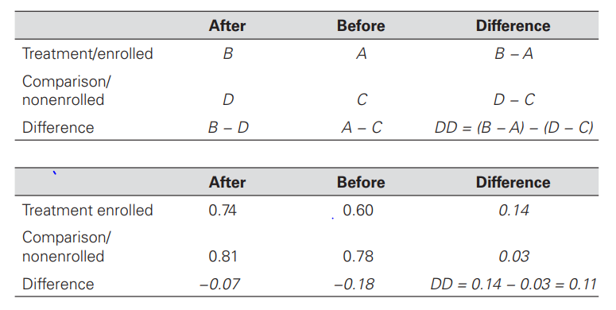
Source – World Bank - Difference-in-Differences
The first row contains outcomes for the treatment group before (A) and after (B) the intervention. The before-and-after comparison for the treatment group is the first difference (B − A). The second row contains outcomes for the comparison group before the intervention (C) and after the intervention (D), so the second (counterfactual) difference is (D − C).
The difference-in-differences method computes the impact estimate as follows:
1. We calculate the difference in the outcome (Y) between the before and after situations for the treatment group (B − A).
2. We calculate the difference in the outcome (Y) between the before and after situations for the comparison group (D − C).
3. Then we calculate the difference between the difference in outcomes for the treatment group (B − A) and the difference for the comparison group (D − C), or DD = (B − A) − (D − C). This “difference-in-differences” is our impact estimate.
Difference-in-differences (DiD) = (B − A) − (D − C)

Final DiD impact = (B − D) − (A − C)
    - Important Advice :
- Be sure outcome trend did not influence allocation of the treatment/intervention
- Acquire more data points before and after to test parallel trend assumption
- Use linear probability model to help with interpretability
- Be sure to examine composition of population in treatment/intervention and control groups before and after intervention
- Use robust standard errors to account for autocorrelation between pre/post in same individual
- Perform sub-analysis to see if intervention had similar/different effect on components of the outcome

- ADVANTAGES & DISADVANTAGES
Advantages :
- Intuitive interpretation
- It can obtain causal effect using observational data if assumptions are met
- It can use either individual or group level data
- Comparison groups can start at different levels of the outcome since DID focuses on change rather than absolute levels
- It accounts for change/change due to factors other than intervention
- The difference in difference method is intuitive and fairly flexible; it will show a causal effect from observational data if the basic assumptions are met. Since it focuses on change, rather than the absolute levels, the groups being compared can start at different levels
- Another key strong point to the DiD method is that it accounts for change due to factors other than the treatment or intervention being studied.

Disadvantages :
- It requires baseline data & a non-intervention group
- It cannot be used if the intervention allocation is determined by baseline outcome
- It cannot be used if the comparison groups have different outcome trend
- It cannot be used if the composition of groups pre/post change are not stable
- Because of serial correlation, conventional DD standard errors may grossly understate the standard deviation of the estimated treatment effects, leading to serious over-estimation of t-statistics and significance levels

Solutions
- Block bootstrap can be used to compute consistent standard errors when the number of groups is sufficiently large
- Collapsing the data into pre- and post- periods produce consistent standard errors, even when the number of states is small
- Allowing for an arbitrary auto-correlation process when computing the standard errors is also a viable solution when the number of groups is sufficiently large

- BEST PRACTICES
- Be sure outcome trend did not influence allocation of the treatment/intervention
- Acquire more data points before and after to test parallel trend assumption
- Use linear probability model to help with interpretability
- Be sure to examine composition of population in treatment/intervention and control groups before and after intervention
- Use robust standard errors to account for autocorrelation between pre/post in same individual
- Perform sub-analysis to see if intervention had similar/different effect on components of the outcome
Some examples of DiD are cited in Revisiting the Difference-in-Differences Parallel Trends Assumption: Part I Pre-Trend Testing

References

Lance, P., D. Guilkey, A. Hattori and G. Angeles. (2014). How do we know if a program made a difference? A guide to statistical methods for program impact evaluation. Chapel Hill, North Carolina: MEASURE Evaluation. Retrieved from: http://www.cpc.unc.edu/measure/publications/ms-14-87-en/
0
Gertler, P. J., Martinez, S., Premand, P., Rawlings, L. B., &Vermeersch, C. M. J. (2010). Impact evaluation in practice. Washington DC: The International Bank for Reconstruction and Development / The World Bank. Retrieved from http://siteresources.worldbank.org/EXTHDOFFICE/Resources/5485726-1295455628620/Impact_Evaluation_in_Practice.pdf

HOW MUCH SHOULD WE TRUST DIFFERENCES-IN-DIFFERENCES ESTIMATES? Marianne Bertrand Esther DufloSendhilMullainathanhttps://economics.mit.edu/files/750

DIFFERENCE IN DIFFERENCES TOOLKIT
This toolkit has been prepared as a ready reference for M & E practitioners. Differences in Differences is a quasi-experimental design that is used to obtain an appropriate counterfactual to estimate a causal effect of a program by comparing changes over time and between a population that is enrolled in the program and a population that is not.

ABOUT DMEO, NITI AAYOG
The Development Monitoring and Evaluation Office (DMEO), attached to NITI Aayog, is the apex monitoring & evaluation (M&E) office in the country, with a mandate to drive evidence-based policy making through M&E of government policies and programmes. Since its inception in 2015, the Office aims to shift the discourse of public policy towards rigorous, data-driven, citizen-centric, and decentralized policymaking, to improve governance and facilitate the formation of a New India.
Visit us at www.dmeo.gov.in

EXPLORE MORE
of DMEO’s thought leadership articles
by visiting https://dmeo.gov.in/articles
This document is produced by advisors and consultants at DMEO, NITI Aayog, as general guidance. It is not intended to provide specific advice. If you require advice or further details on any matters referred in this document, please contact DMEO.

Copyright © 2020 NITI Aayog.
All rights reserved.

