TOOLKIT
PARTICIPANT OBSERVATION

July 2020
- BACKGROUND
Participant observation is a qualitative evaluation study tool in which the evaluator enters a local group in order to gain understanding of the internal structure of the society. Participant observation provides the researcher with access to different types of information that may not be easily accessible to outsiders.
- GOAL
The goal of participant observation is to gain a deep understanding and familiarity with a certain group of individuals, their values, beliefs, and way of life. Data obtained through participant observation serve as a check against participants’ subjective reporting of what they believe and do. Participant observation is also useful for gaining an understanding of the physical, social, cultural, and economic contexts in which study participants live; the relationships among and between people, contexts, ideas, norms, and events; and people’s behaviours and activities – what they do, how frequently, and with whom.
- ADVANTAGES AND DISADVANTAGES
  - Advantages
- It provides information directly to the evaluator, thereby reducing the dependency on someone else.
- Produces rich qualitative data which shows picture of how people really live. Researcher can see for themselves.
- Allows for insight into contexts, relationships, behaviour.
- Can provide information previously unknown to researchers that is crucial for project design, data collection, and interpretation of other data.
- It is a discovery oriented and flexible process.
  - Disadvantages
- It can be time consuming and biased sometimes.
- Presence of an outsider may lead to changed behaviour of the locals, which can cause errors in data collection
- It generates a vast amount of data.
- Active involvement in the group can cause the researcher to lose objectivity and may lead to bias.
- It can take a long time for the group to accept the researcher as a member and become comfortable with him or her.
- It’s difficult to participate, observe, and take notes at the same time.
- Documentation relies on memory, personal discipline, and diligence of researcher
- WHEN TO USE PARTICIPANT OBSERVATION
- This method is used to create a better understanding of the locals, their social and cultural norms etc.
- It is used to add validity to our monitoring efforts and helps us to verify if people are doing something different from what they say that they do.

REFERENCES
Figure 1 (Kawulich, 2005) https://www.fhi360.org/sites/default/files/media/documents/Qualitative%20Research%20Methods%20-%20A%20Data%20Collector's%20Field%20Guide.pdf
Figure 2 (Mack et al., 2005)
http://www.qualitative-research.net/index.php/fqs/article/view/466/996

- ROLE OF FACILITATORS
  - Defining Responsibilities
- Researchers conducting participant observation need to be prepared and willing to adapt to a variety of uncontrolled situations and settings.
- Observing people as they engage in activities that would probably occur in much the same way if you were not present
- Engaging to some extent in the activities taking place, either in order to better understand the local perspective or so as not to call attention to yourself
- Interacting with people socially outside of a controlled research environment, such as at a bar, public meeting place, bus depot, religious gathering, or market – if casual conversation gives way to more substantive discussion of the research topic, you would need to disclose your identity, affiliation, and purpose.

- ETHICAL GUIDELINES
  - Disclosing information about participant
Normal activities should not be disturbed. You should never be secretive or deliberately misleading about the research project or your role in it. If someone asks directly what you are doing, always provide a truthful response. Be open, polite, and cognizant of your position as a guest or outsider
  - Maintaining Confidentiality
As with all qualitative methods, researchers involved in participant observation must make a personal commitment to protect the identities of the people they observe or with whom they interact, even if informally. Maintaining confidentiality means ensuring that particular individuals can never be linked to the data they provide. This means that you must not record identifying information such as names and addresses of people you meet during participant observation.
  - Informed Consents
It is not necessary to obtain formal informed consent for participant observation. They are not required to talk to you and that there will be no repercussions if they do not.

Steps to Conduct Participant Observation
  - Deciding Initial Research
- To do some initial research to learn about the domain, the users, and their activities.
- Look at any previous research that others have done on the topic. This will help you to determine where to focus your research.
  - Deciding Objective of the Study
- Clearly determine the goals of the research and the questions that you want to answer.
- Clearly determine the groups, the people and the activities that you want to observe.

  - Deciding Location of Observation

- To go where people in the study population often go in their daily lives, and if appropriate, engage in the activity of interest. A key informant could tell you where those places are.
- Participant observation may be done individually, in pairs, and in teams – whichever arrangement is most appropriate for covering the locations and topics at issue. Factors often considered in determining the appropriate arrangement include the age, gender, physical appearance, ethnicity, personality, and linguistic abilities of different data collectors. The objective should be to gather data in the least obtrusive and most efficient manner possible.
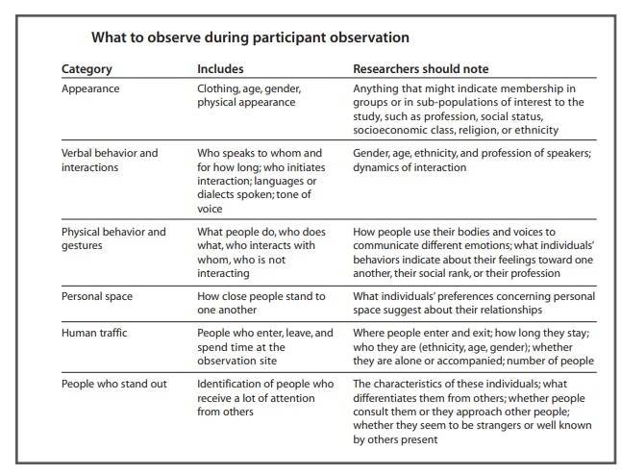
  - Deciding Time of Observation
Figure 3 Table 1 (Mack et al.,2005) https://www.fhi360.org/sites/default/files/media/documents/Qualitative%20Research%20Methods%20-%20A%20Data%20Collector's%20Field%20Guide.pdf
- The best time to schedule participant observation sessions depends on what, whom, and where you need to observe. You may need to set up specific times based on when the particular activity takes place. There might be specific times of day when an activity usually occurs, as at bars or public parks. It may also be important to observe the same population in several different locations and at different times.
  - Deciding the Number of Observers
- To conduct participant observation either alone or with two or more other observers.
- If each observer participates in a different group, data will have greater reliability.
- Observing only one group doesn’t reveal whether characteristics, behaviours, actions, and situations are unique to that group or common across groups.
- One observer is also more susceptible to bias and the subjective interpretation of data. Combining data from multiple observers helps to overcome such difficulties.
  - Duration for each Observation
- The specific duration of participant observation depends on the setting, activity, and population of interest. For example, the researcher might spend an hour, an afternoon, or a series of afternoons in a particular setting
  - Identifying Key informants
- Key informants with personal connections to the study population can be invaluable. They may not be appropriate study participants themselves but may be willing to serve as liaisons to the community
- Researchers often find such individuals at a field site by chance. You might identify as a key informant someone toward whom other people seem to migrate
  - Documentation and Data Analysis

7.8.1. Documentation
- Documentation of participant observation data consists of field notes recorded in field notebooks. These data are records of what you experienced, what you learned through interaction with other people, and what you observed. What you should note depends on your research questions, but in general, some things to capture are
- the people
- social behavior
- frequency of actions
- duration of actions
- body language
- interactions between people
- tools and artifacts that participants use
- environmental factors
- Audio and video recordings of participant observation are generally not permissible in applied public health or international development research activities because of ethical requirements for obtaining informed consent.

7.8.2. Utility of Field Notes
As soon as possible after collecting participant observation data, you should expand whatever notes you were able to make into a descriptive narrative, alternatively, rather than expanding your notes, you might be asked to share your notes with other members of the research team to produce a joint product, such as an ethnographic map of an area.

7.8.3. Sharing data with research team
Team meetings typically take place throughout data collection but are more frequent at the beginning of a project. At such meetings, be prepared to discuss what you have seen, raise questions about the meaning or implications of your observations, and suggest how your observations might be followed up in interviews, focus groups, or in further observation. Also, discuss any logistical or security concerns that emerge.

7.8.4. Expanding Notes
Scheduling time to expand your notes, preferably within 24 hours from the time field notes are made. A good technique for expanding your notes is to write a narrative describing what happened and what you learned about the study population and setting. Write down questions about participant responses that need further consideration or follow-up, issues to pursue, new information, etc. Finally, Review the expanded notes and add any final comments.

READY REFERENCE
- https://www.fhi360.org/sites/default/files/media/documents/Qualitative%20Research%20Methods%20-%20A%20Data%20Collector's%20Field%20Guide.pdf
- http://www.qualitative-research.net/index.php/fqs/article/view/466/996
- https://www.fhi360.org/sites/default/files/media/documents/Qualitative%20Research%20Methods%20-%20A%20Data%20Collector's%20Field%20Guide.pdf )
- https://youtu.be/ZAkrP9bFXzA

PARTICIPANT OBSERVATION TOOLKIT
This toolkit has been prepared as a ready reference for M & E practitioners. Participant observation is a qualitative evaluation study tool in which the evaluator enters a local group in order to gain understanding of the internal structure of the society and get access to different types of information that may not be easily accessible to outsiders.

ABOUT DMEO, NITI AAYOG
The Development Monitoring and Evaluation Office (DMEO), attached to NITI Aayog, is the apex monitoring & evaluation (M&E) office in the country, with a mandate to drive evidence-based policy making through M&E of government policies and programmes. Since its inception in 2015, the Office aims to shift the discourse of public policy towards rigorous, data-driven, citizen-centric, and decentralized policymaking, to improve governance and facilitate the formation of a New India.
Visit us at www.dmeo.gov.in
EXPLORE MORE
of DMEO’s thought leadership articles
by visiting https://dmeo.gov.in/articles
This document is produced by advisors and consultants at DMEO, NITI Aayog, as general guidance. It is not intended to provide specific advice. If you require advice or further details on any matters referred in this document, please contact DMEO.

Copyright © 2020 NITI Aayog.
All rights reserved.

